Ex.no:7b | DATA VISUALIZATION USING TABLEAU-  WORLD HAPPINESS DATASET

Aim

To connect, analyze, visualize, and create an interactive dashboard using Tableau with the World Happiness Dataset to analyze happiness patterns, region-wise happiness, country-wise happiness, happiness distribution, happiness trends over time, and the factors influencing happiness.

Software Requirements

• Tableau Desktop / Tableau Public
• Microsoft Excel
• CSV Dataset
• Windows Operating System

Theory

Tableau is a powerful Business Intelligence (BI) and Data Visualization tool used to create interactive dashboards and reports.

The World Happiness Dataset contains information related to happiness scores and various factors influencing happiness across different countries from 2015 to 2024.

The dataset includes:
- Ranking
- Country
- Regional indicator
- Happiness score
- GDP per capita
- Social support
- Healthy life expectancy
- Freedom to make life choices
- Generosity
- Perceptions of corruption
Tableau allows users to analyze this data and identify happiness trends over time, compare happiness across regions and countries, analyze happiness distribution, and study the factors influencing happiness.

Tableau Architecture

World Happiness Dataset

↓

Data Connection

↓

Worksheets

↓

Visualizations

↓

Dashboard

↓

Story

Learning Outcomes

After completing this experiment, students will be able to:

✓ Connect the World Happiness Dataset to Tableau
✓ Create worksheets using dimensions and measures
✓ Generate different charts and visualizations
✓ Analyze happiness trends over time
✓ Compare happiness across different regions and countries
✓ Analyze happiness distribution
✓ Apply filters and parameters
✓ Create calculated fields
✓ Build interactive dashboards
✓ Create stories for World Happiness analysis

Sample Dataset

Food Waste Prediction Dataset

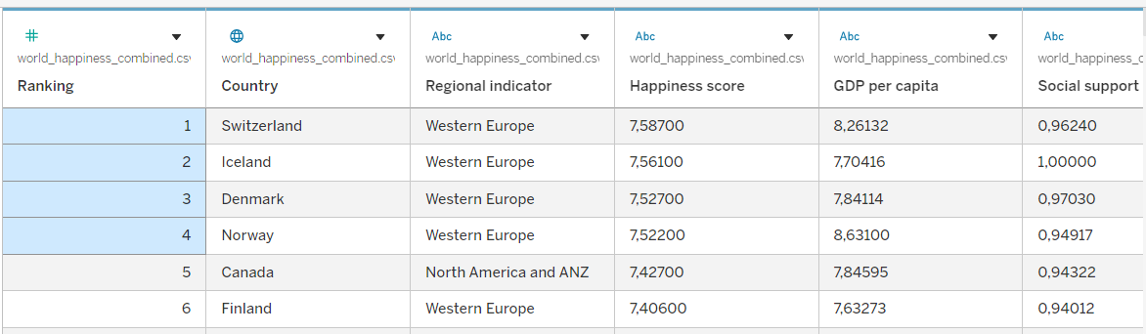

The actual GTD contains a much larger number of records and columns.

Algorithm 1 – Connecting Data Source

Step 1

Open Tableau Desktop.

Step 2

Select Connect.

Step 3

Choose Microsoft Excel or Text File depending on the dataset format.

Step 4

Browse and select the World Happiness Dataset.

Step 5

Open the dataset.

Step 6

Verify the imported fields such as:
- Ranking
- Country
- Regional indicator
- Happiness score
- GDP per capita
- Social support
- Healthy life expectancy
- Freedom to make life choices
- Generosity
- Perceptions of corruption

Procedure

Tableau

↓

Connect

↓

Excel / Text File

↓

World Happiness Dataset

↓

Open

↓

Verify Data

Output

World Happiness Dataset loaded into Tableau successfully.

Algorithm 2 – Creating Worksheet

Step 1

Open Sheet 1.

Step 2

Drag Regional Indicator to Rows.

Step 3

Drag Happiness Score Numeric to Columns.

Step 4

Select Bar Chart from the visualization options.

Step 5

Enable Show Mark Labels to display the Average happiness score for each region.

Step 6

Sort the regions in descending order based on Happiness Score Numeric.

Step 7

Add the title Regional Happiness Analysis.

Output

Worksheet created successfully.

Interpretation

The bar chart displays the average happiness score for each region. It helps compare happiness levels across different regions and identify regions having the highest and lowest average happiness scores.

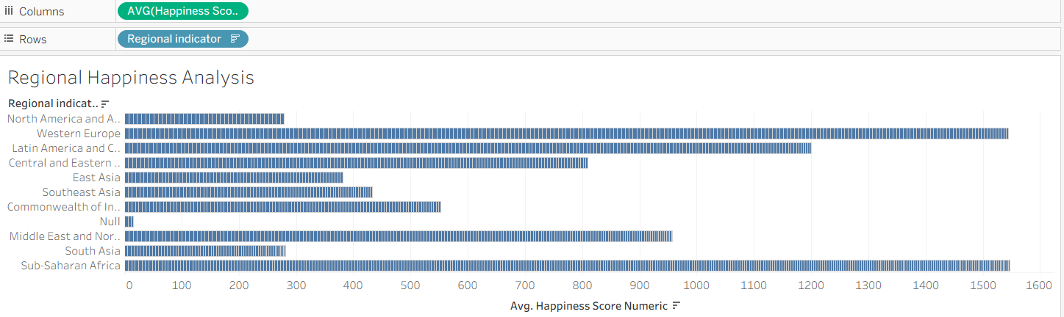

Algorithm 3 – Bar Chart Creation

Objective

To compare the happiness scores across different countries.

Step 1

Drag Country → Rows.

Step 2

Drag Happiness Score Numeric→ Columns.

Step 3

Select Bar Chart from Show Me.

Step 4

Enable Show Mark Labels.

Step 5

Sort the countries in descending order

Output Visualization

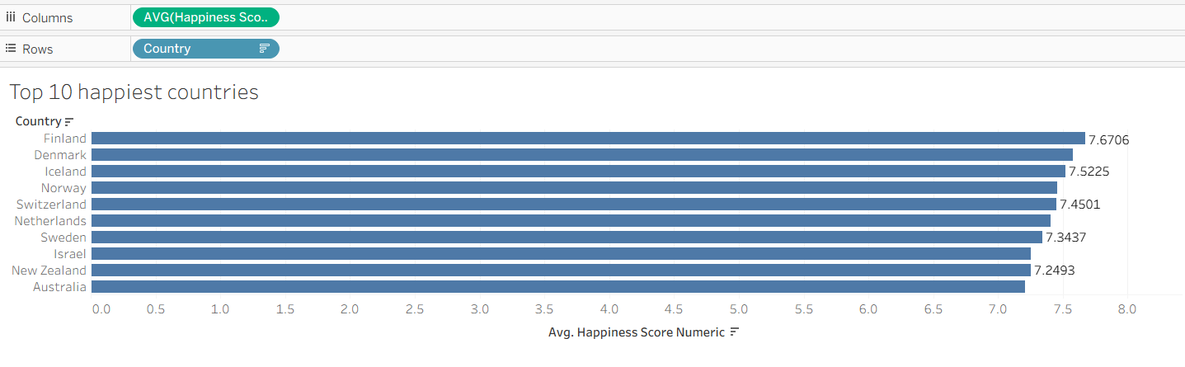

Interpretation

The bar chart helps identify the countries having higher and lower happiness scores. The Top 10 filter highlights the countries with the highest average happiness scores.

Algorithm 4 – Pie Chart Creation

Objective

To analyze the distribution of happiness scores based on different regions.

Step 1

Drag Regional indicator to the view.

Step 2

Select Pie Chart from Show Me.

Step 3

Drag Happiness Score Numeric to Angle.

Step 4

Drag Regional indicator to Color.

Step 5

Enable Show Labels.

Output Visualization

Happiness Distribution by Region Pie Chart

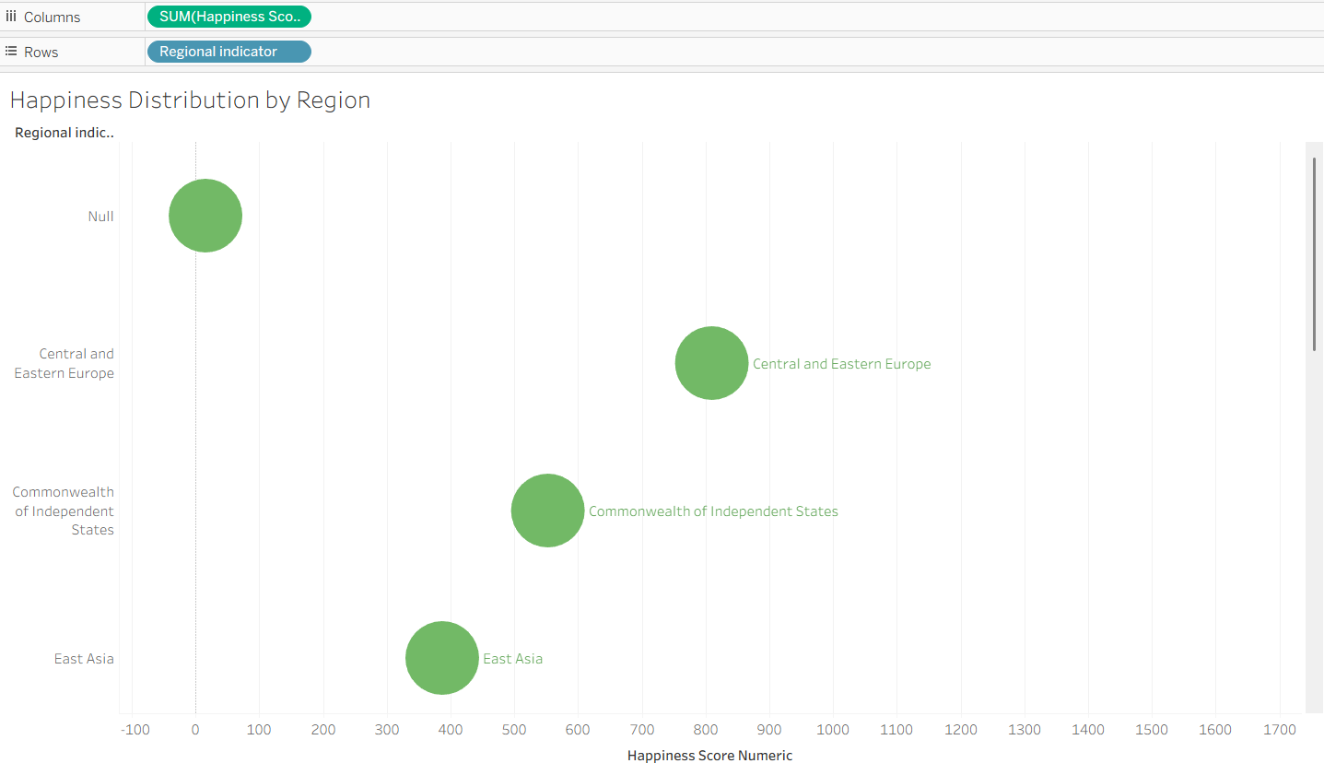

Interpretation

The pie chart shows the contribution of different regions to the overall happiness score in the dataset.

Algorithm 5 – Line Chart Creation

Objective

To analyze the trend of happiness scores over time.

Step 1

Drag Year → Columns.

Step 2

Drag Happiness Score Numeric → Rows.

Step 3

Select Line Chart.

Step 4

Enable data labels if required.

Step 5

Analyze the happiness score trend over different years.

Output Visualization

World Happiness Trend Over Time

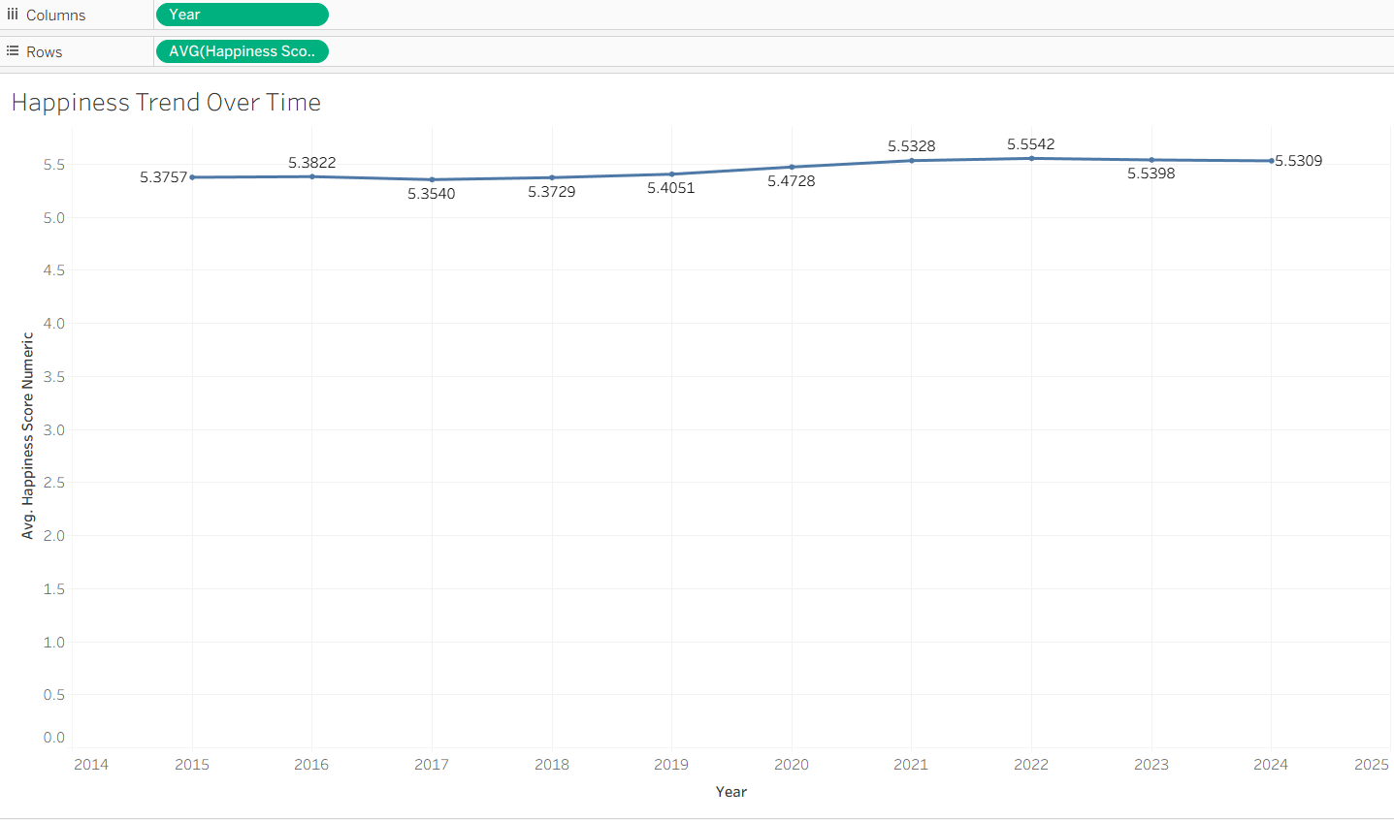

Interpretation

The line chart shows how the average happiness score changes over time.

It helps identify:
- Increasing happiness trends
- Decreasing happiness trends
- Years with higher happiness scores
- Years with lower happiness scores
- Changes in overall happiness levels

Algorithm 6 – Creating Calculated Field

Objective

To calculate a normalized happiness score based on GDP per capita.

Step 1

Select:

Analysis → Create Calculated Field

Step 2

Enter the field name:

Happiness Score per GDP

Step 3

Enter the formula:

[Happiness Score Numeric] / [GDP per capita]

Step 4

Click OK.

Output
Restaurant Name | Prepared Quantity | Remaining Quantity | Remaining Food Percentage
Food Hub | 150 | 20 | 13.33%
Green Bowl | 140 | 25 | 17.86%
Ocean Treat | 180 | 25 | 13.89%

Interpretation

The calculated field helps analyze the relationship between the happiness score and GDP per capita and provides a normalized measure for comparing happiness relative to economic conditions.

Algorithm 7 – Applying Filters

Objective

To analyze happiness for a specific region.

Step 1

Drag Regional indicator to the Filters.

Step 2

Select the required region.

Step 3

Click Show Filter.

Step 4

Select a region from the filter.

Step 5

Observe the updated charts.

Example

Filter: Regional indicator = Western Europe

Output

The visualizations display only the World Happiness records belonging to the selected region.

Interpretation

The Regional indicator filter allows users to focus on a particular region and perform detailed happiness analysis.

Algorithm 8 – Creating Parameter

Objective

To dynamically display countries based on a user-defined minimum happiness score.

Step 1

Select:

Create Parameter

Step 2

Specify the parameter name:

Minimum Happiness Score

Step 3

Set the data type as:

Float

Step 4

Set the required minimum value.

Step 5

Create a calculated field using the parameter.

Formula

[Happiness Score Numeric] >= [Minimum Happiness Score]

Example

Minimum Happiness Score = 6.00

Output

The visualization displays countries where the Happiness Score is greater than or equal to the selected minimum value.

Interpretation

The parameter allows users to dynamically identify high-happiness countries based on a selected happiness-score threshold.

Algorithm 9 – Dashboard Creation

Objective

To create an interactive World Happiness Analysis Dashboard.

Step 1

Create multiple worksheets.

Step 2

Select Dashboard → New Dashboard.

Step 3

Drag the required worksheets into the dashboard.

Step 4

Arrange the charts clearly.

Step 5

Add filters for:
- Regional indicator
- Country
- Year

Step 6

Add the Minimum Happiness Score parameter.

Step 7

Add appropriate titles and labels.

Dashboard Analysis

Average Happiness Score

Average of Happiness Score Numeric.

Maximum Happiness Score

Maximum of Happiness Score Numeric.

Minimum Happiness Score

Minimum of Happiness Score Numeric.

Average GDP per Capita

Average of GDP per capita.

Total Remaining Quantity

Sum of Remaining Quantity.

Interpretation

The dashboard provides a consolidated view of global happiness levels, regional performance, country rankings, happiness trends, and influencing factors and allows users to interactively analyze the data using filters and parameters.

Algorithm 10 – Story Creation

Objective

To present the analysis of World Happiness and its influencing factors through a sequence of visual insights.

Step 1

Create the required worksheets.

Step 2

Create the World Happiness Analysis Dashboard.

Step 3

Select Story → New Story.

Step 4

Add the dashboard and required worksheets as story points.

Step 5

Arrange the story points in a logical sequence.

Step 6

Present the findings.

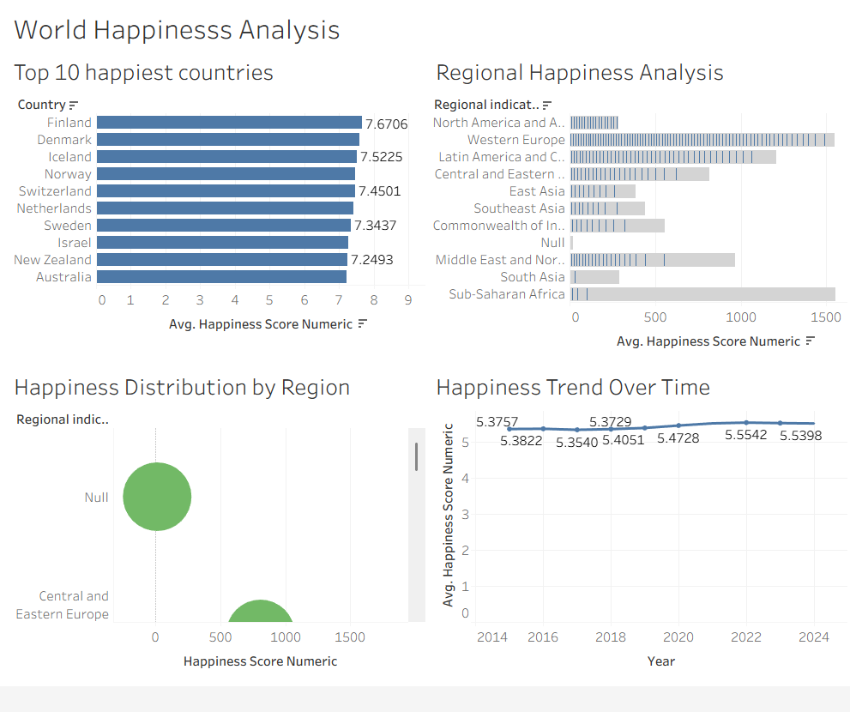

Example Story

Story Point 1

Overall World Happiness Analysis

Displays the average happiness score, maximum happiness score, minimum happiness score, GDP per capita, and social support.

Story Point 2

World Happiness Trend Over Time

Shows how the average happiness score changes across different years

Story Point 3

Regional Happiness Analysis

Shows how the average happiness score changes across different years.

Story Point 4

Happiness Distribution by Region

Shows the distribution of happiness scores among different regions.

Story Point 5

Top 10 Happiest Countries

Compares the countries having the highest happiness scores.

Story Point 6

Final World Happiness Analysis

Summarizes the major patterns and observations obtained from the dataset.

Applications

Happiness Analysis

Analysis of happiness scores and factors influencing happiness across different countries and years.

Regional Comparison

Identification of regions with higher and lower average happiness levels.

Country Comparison

Comparison of happiness scores among different countries.

Economic Analysis

Analysis of the relationship between happiness and GDP per capita.

Social Analysis

Analysis of the relationship between happiness and social support.

Business Intelligence

Interactive visualization and dashboard-based World Happiness analysis.

Decision Making

Identification of regions and countries with high and low happiness levels for better policy and planning decisions.

Result

